**Objective: To implement queries using  *Union, Intersect, Minus, subqueries (nested queries)***

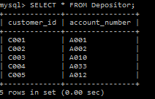 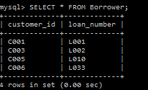

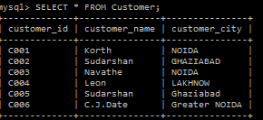

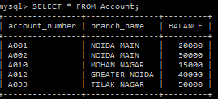

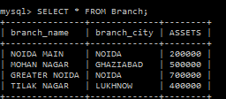

**SQL Queries**

**Use Union, Intersect, Minus**

1. Find the Customer Ids of those customers who are having a loan or an account or both. (Union)

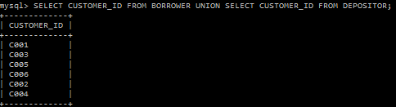

1. Find the Customer Ids of those customers who are having a loan and account both. (Intersect)

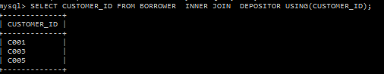

1. Find the Customer Ids of those customers who are having loan but not an account. (Minus)

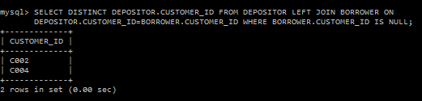

1. Find the Customer Ids of those customers who are having account but not loan. (Minus)

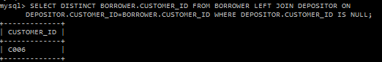

**Use Sub-queries**

5. Find customer ids of those customers who are borrower from the banks and who appear in the list of account holders.

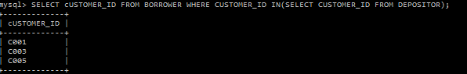

6. Find those customer names who are borrower.

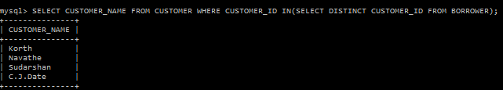

7. Find the name of the customers who have a loan from the bank, but do not have an account at the bank. (Hint: use NOT IN)

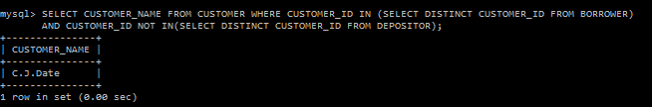

8. Get the Customer Id and name of those customers who have both account and loan from the bank.

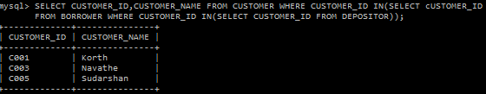

9. Get Branch Name of the branch having highest average balance amongst all branches.

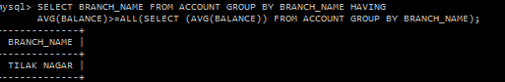

1. Find the names of all branches that have assets greater than those of at least one branch located in NOIDA.

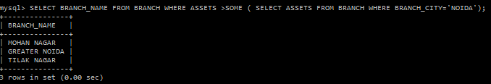

1. Find the names of all branches that have assets greater than that of each branch located in NOIDA



12. Get the names of the customers who have account in each branch located in Noida.

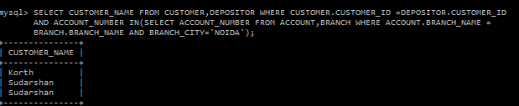

**Abhishek Chopra**

**1403210009**

**CSE-A**

**DBMS Assignment 3**